2022 Annual Report for the Partnership with the Diocese of Meru,
and our Partner Parishes Kikwe and Karangai

Hard to believe, but 2022 was our 15th year of partnership with Kikwe and Karangai, our parish partners in the Diocese of Meru in Tanzania, Africa! There have been many blessings on both sides of this partnership, and the love and prayers we share are certainly not the least of those.
Life is never easy in this area of Eastern Africa; rain is historically scarce, but 2022 was the third consecutive year of a drought that has only become more severe as each year passes. About 5 years ago, the Greater Milwaukee Synod (GMS) was able to build a pipeline from a spring on the south side of Mt. Meru to a cistern in Kikwe Parish that has become a lifesaving source of clean drinking water for the area. Presently we are very close to being able to extend that pipeline further south to Karangai, with the people of Karangai pledging to dig the trench for the pipe in order to keep the cost as low as possible.
While the people in Kikwe and Karangai are grateful for the safe water to drink, without rainfall there is not enough water to sustain crops and livestock. In 2022 all crops in the area failed, and livestock are dying due to lack of food and water. The people too, are desperate for food which, while generally available has become prohibitively expensive. The GMS formed a Hunger Relief subcommittee to raise money and send it to the Diocese for them to buy food such as corn, beans, rice, and cooking oil.
To date over $101,000 has been raised and sent, and I’m pleased and proud to say that over $4,000 of that came from RLC. But when 220 pounds of corn, which can provide 65 family meals costs $65 or more, you can see that even that large amount of money doesn’t go far enough. So, we must continue to help until crops can be harvested. Rain has started to come to some areas of the Meru Diocese; please pray that the rains are gentle and that they’ll continue to fall regularly.
Once again, our partners astound us with their faith. “When the rains come, we will plant again!” is what we always hear. These are faithful, hard-working people that are an inspiration to me and everyone I know who has been there and met them.
RLC has also sent Kikwe and Karangai gifts of $3,000 each from Harvest Faire. As I wrote to them, “We are hopeful that this money can be used for school scholarships, but we know the needs are many and we trust the Pastor(s) and the Partnership Committee(s) to use the money where it will provide the most benefit.”
Our partners at Kikwe, Pastor Kaanankira Mbise and partnership committee chairperson Mrs. June Kanji, and our partners at Karangai, Pastor Patrick Nassary and partnership committee chairperson Mr. Exaudi Mungure, are most grateful for our partnerships as well as our gifts. Every month we exchange prayer requests for our Common Day of Prayer the first Sunday of each month, and each month their first prayer is thanks to God and blessings for us, their brothers and sisters in Christ.
Covid-19 has severely limited travel to Tanzania for the past 3 years now which has been a significant financial loss to the country as a whole, but in 2023 there are several trips already planned by other partner congregations. We are also considering a trip, perhaps sometime in the first half of 2024. If you are interested in participating in this partnership and/or traveling to Tanzania, please let me or Dave Chappell know.
As they say at Kikwe and Karangai, Asante Sana, Mungu Awabariki! (Thank you, God Bless you!).
Respectfully submitted,
Andy Toth
President, GMS Meru Partnership Committee
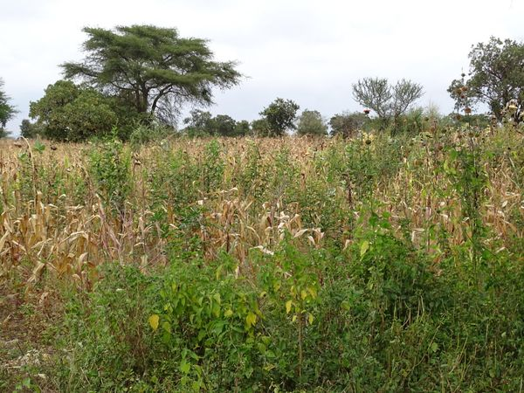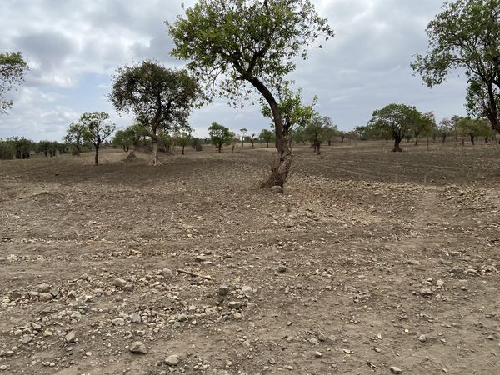
Effects of the drought - pictures of the same area: Left, in 2018; Right in 2022
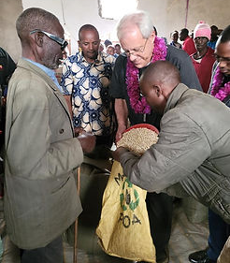
GMS Bishop Paul Erickson distributing
food at a parish in the Diocese of Meru

